Project title: OutReach.

Number and Duration of Placements: 5 persons for 6 months

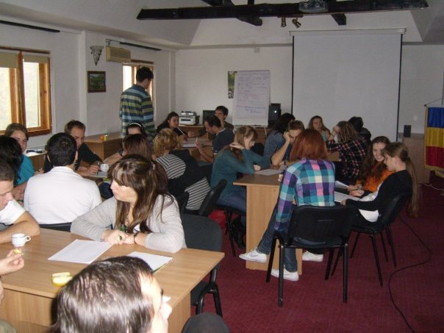

Venue: Bucharest, Romania

Dear friends and colleagues, we are looking for: 6-8 Partner organizations to participate in our EVS Project "OutReach" for the 1st of July YiA Deadline.

Partners will be involved in the design and implementation of the project and recruitment process of the Volunteers. The sending organization must be accredited for sending EVS volunteers.

Short Description of the project: We are looking to build a group of volunteers that will be working with children that come from disadvantaged backgrounds. Volunteers will be working with communities mainly in Bucharest and could also have some actions in Husi and Ploiesti. The volunteers will also be involved in developing, writing and managing projects on non-formal education within our team.

The project will start on 1st of November 2010, and volunteers should arrive in Romania in January 2011.

Interested organizations please send the Stamped and signed Part III before May 7th to the following e-mail address: office@caddru.ro , atechs@gmail.com

For detailed information please contact Alex Done (EVS Coordinator of C.A.D.D.R.U.) : office@caddru.ro , atechs@gmail.com

Best Regards
Alex Done

C.A.D.D.R.U. team

